**Mathematics**

**Formulas, rules, tables, theorems, and other things…**

Notes:

|  |
| --- |
|  |
|  |
|  |
|  |
|  |
|  |
|  |
|  |
|  |
|  |
|  |
|  |
|  |
|  |
|  |
|  |
|  |
|  |
|  |
|  |
|  |
|  |
|  |
|  |
|  |

Order of Operations

|  |  |
| --- | --- |
| *operation* | *example* |
| Parentheses | 4 × (3 + 8) = 4 × 11 |
| Exponents | 3 × 52 = 3 × 25 |
| Multiplication | 4 + 3 × 5 = 4 + 15 |
| Division | 12 ÷ 3 + 20 ÷ 5 = 4 + 4 |
| Addition | 10 + 3 × 2 = 10 + 6 |
| Subtraction | 12 – 8 ÷ 2 = 12 - 4 |

**Mathematical Symbols**

|  |  |  |
| --- | --- | --- |
| Symbol | Means | Example |
| $$=$$ | is equal to | $$\frac{1}{4}=0.25$$ |
| $$≠$$ | is not equal to | $$\frac{1}{4}≠0.4$$ |
| $$≈$$ | is approximately equal to | $$\frac{1}{3}≈0.3$$ |
| $$≡$$ | is equivalent to | $$\frac{1}{7}≡7^{-1}$$ |
| $$<$$ | is less than | $$0.6<\frac{2}{3}$$ |
| $$>$$ | is greater than | $$0.7>\frac{2}{3}$$ |
| $$≤$$ | is less than or equal to | |
| $$≥$$ | is greater than or equal to | |

**MULTIPLICATION CHART**

|  |  |  |  |  |  |  |  |  |  |  |
| --- | --- | --- | --- | --- | --- | --- | --- | --- | --- | --- |
| **x** | **1** | **2** | **3** | **4** | **5** | **6** | **7** | **8** | **9** | **10** |
| **1** | **1** | **2** | **3** | **4** | **5** | **6** | **7** | **8** | **9** | **10** |
| **2** | **2** | **4** | **6** | **8** | **10** | **12** | **14** | **16** | **18** | **20** |
| **3** | **3** | **6** | **9** | **12** | **15** | **18** | **21** | **24** | **27** | **30** |
| **4** | **4** | **8** | **12** | **16** | **20** | **24** | **28** | **32** | **36** | **40** |
| **5** | **5** | **10** | **15** | **20** | **25** | **30** | **35** | **40** | **45** | **50** |
| **6** | **6** | **12** | **18** | **24** | **30** | **36** | **42** | **48** | **54** | **60** |
| **7** | **7** | **14** | **21** | **28** | **35** | **42** | **49** | **56** | **63** | **70** |
| **8** | **8** | **16** | **24** | **32** | **40** | **48** | **56** | **64** | **72** | **80** |
| **9** | **9** | **18** | **27** | **36** | **45** | **54** | **63** | **72** | **81** | **90** |
| **10** | **10** | **20** | **30** | **40** | **50** | **60** | **70** | **80** | **90** | **100** |

Products of Prime Factors

How many ways, using multiplication, can you make 60?

1 x 60, 2 x 30, 3 x 20, 4 x 15, 5 x 12, 6 x 10, 10 x 6, 12 x 5,

15 x 4, 20 x 3, 30 x 2, 60 x 1

There is only way one to make 60 as a *product of its prime factors*:

60 = 2 x 2 x 3 x 5

or

60

30

15

5

1

2

2

3

5

60

15

5

2

2

3

4

Fraction Wall

|  |  |  |  |  |  |  |  |  |  |  |  |  |  |  |  |  |  |  |  |
| --- | --- | --- | --- | --- | --- | --- | --- | --- | --- | --- | --- | --- | --- | --- | --- | --- | --- | --- | --- |
|  |  | |  | |  |  | | |  |  |  | | |  |  | |  | |  |
|  | |  | | |  | |  | | |  | | |  | |  | | |  | |
|  | | |  | | |  | | | |  | | | |  | | |  | | |
|  | | | |  | | | |  | | | |  | | | |  | | | |
|  | | | | |  | | | | |  | | | | |  | | | | |
|  | | | | | |  | | | | | | | |  | | | | | |
|  | | | | | | | | | |  | | | | | | | | | |
|  | | | | | | | | | | | | | | | | | | | |

Fractions, decimals and percentages

|  |  |  |
| --- | --- | --- |
|  | 0.5 | 50% |
|  | or 0.333…  or 0.33 | 33.3% |
|  | or 0.666…  or 0.667 | 66.7% |
|  | 0.25 | 25% |
|  | 0.75 | 75% |
|  |  | 20% |
|  |  | 40% |
|  | 0.1 | 10% |

Fractions Addition and Subtraction

=

+







+

=







*Why twelfths?*

-

=







*Why sixths?*

Decimals

place value and fractional equivalence

One of my favorite numbers is 1.618034….

|  |  |  |  |  |  |  |  |
| --- | --- | --- | --- | --- | --- | --- | --- |
| 1 |  | 6 | 1 | 8 | 0 | 3 | 4 |
| One unit | the decimal point |  |  |  |  |  |  |
|  |  |  |  |  |  |
|  |  |  |  |  |  |
|  |  |  |  |  |  |
|  |  |  |  |  |  |
|  |  |  |  |  |  |

Rounding

When rounding a decimal, think about the degree of accuracy you need. In this example, the last figure represents *four millionths*.

When you calculate a length, would you need it to be accurate to a millionth of a centimeter?

Rounding and Estimation

*Approximate to specified or appropriate degrees of accuracy including a given power of ten, number of decimal places and significant figures*

|  |  |
| --- | --- |
| **Skill** | **Example** |
| * Round numbers to a given power of 10 | Round 13 672 to the nearest thousand:  14 000 |
| * Rounding to a given number of decimal places | Round 1.618034 to two decimal places:  1.62 |
| * Round to the nearest integer and to any given number of significant figures | Round 341 217 to two significant figures:  340 000 |
| * Estimate answers to calculations, including use of rounding | Estimate the solution to: $\frac{12.79×26.8}{0.479}$ $$\frac{10×30}{0.5}=\frac{300}{0.5}=600$$ |

**Positive and Negative Numbers**

***Addition and Subtraction***

|  |  |  |  |  |  |  |  |  |  |  |
| --- | --- | --- | --- | --- | --- | --- | --- | --- | --- | --- |
| 3 | + | 3 | = | 6 |  | 3 | - | 3 | = | 0 |
| 3 | + | 2 | = | 5 |  | 3 | - | 2 | = | 1 |
| 3 | + | 1 | = | 4 |  | 3 | - | 1 | = | 2 |
| 3 | + | 0 | = | 3 |  | 3 | - | 0 | = | 3 |
| 3 | + | -1 | = | 2 |  | 3 | - | -1 | = | 4 |
| 3 | + | -2 | = | 1 |  | 3 | - | -2 | = | 5 |
| 3 | + | -3 | = | 0 |  | 3 | - | -3 | = | 6 |
| 3 | + | -4 | = | -1 |  | 3 | - | -4 | = | 7 |
| 3 | + | -5 | = | -2 |  | 3 | - | -5 | = | 8 |
| 3 | + | -6 | = | -3 |  | 3 | - | -6 | = | 9 |
|  |  |  |  |  |  |  |  |  |  |  |
| 3 | + | 3 | = | 6 |  | 3 | - | 3 | = | 0 |
| 2 | + | 3 | = | 5 |  | 2 | - | 3 | = | -1 |
| 1 | + | 3 | = | 4 |  | 1 | - | 3 | = | -2 |
| 0 | + | 3 | = | 3 |  | 0 | - | 3 | = | -3 |
| -1 | + | 3 | = | 2 |  | -1 | - | 3 | = | -4 |
| -2 | + | 3 | = | 1 |  | -2 | - | 3 | = | -5 |
| -3 | + | 3 | = | 0 |  | -3 | - | 3 | = | -6 |
| -4 | + | 3 | = | -1 |  | -4 | - | 3 | = | -7 |
| -5 | + | 3 | = | -2 |  | -5 | - | 3 | = | -8 |
| -6 | + | 3 | = | -3 |  | -6 | - | 3 | = | -9 |

**Positive and Negative Numbers**

***Multiplication and Division***

|  |  |  |  |  |  |  |  |  |  |  |
| --- | --- | --- | --- | --- | --- | --- | --- | --- | --- | --- |
| 3 | × | 3 | = | 9 |  | 9 | ÷ | 3 | = | 3 |
| 2 | × | 3 | = | 6 |  | 6 | ÷ | 3 | = | 2 |
| 1 | × | 3 | = | 3 |  | 3 | ÷ | 3 | = | 1 |
| 0 | × | 3 | = | 0 |  | 0 | ÷ | 3 | = | 0 |
| -1 | × | 3 | = | -3 |  | -3 | ÷ | 3 | = | -1 |
| -2 | × | 3 | = | -6 |  | -6 | ÷ | 3 | = | -2 |
| -3 | × | 3 | = | -9 |  | -9 | ÷ | 3 | = | -3 |
| -4 | × | 3 | = | -12 |  | -12 | ÷ | 3 | = | -4 |
| -5 | × | 3 | = | -15 |  | -15 | ÷ | 3 | = | -5 |
| -6 | × | 3 | = | -18 |  | -18 | ÷ | 3 | = | -6 |
|  |  |  |  |  |  |  |  |  |  |  |
| 3 | × | -3 | = | -9 |  | -9 | ÷ | -3 | = | 3 |
| 2 | × | -3 | = | -6 |  | -6 | ÷ | -3 | = | 2 |
| 1 | × | -3 | = | -3 |  | -3 | ÷ | -3 | = | 1 |
| 0 | × | -3 | = | 0 |  | 0 | ÷ | -3 | = | 0 |
| -1 | × | -3 | = | 3 |  | 3 | ÷ | -3 | = | -1 |
| -2 | × | -3 | = | 6 |  | 6 | ÷ | -3 | = | -2 |
| -3 | × | -3 | = | 9 |  | 9 | ÷ | -3 | = | -3 |
| -4 | × | -3 | = | 12 |  | 12 | ÷ | -3 | = | -4 |
| -5 | × | -3 | = | 15 |  | 15 | ÷ | -3 | = | -5 |
| -6 | × | -3 | = | 18 |  | 18 | ÷ | -3 | = | -6 |

**Percentages**

|  |  |  |
| --- | --- | --- |
| Start value | % change | End value |
| ✓ | ✓ | ? |

Find the increase:

 or 

and simply add it on to the original value.

|  |  |  |
| --- | --- | --- |
| Start value | % change | End value |
| ✓ | ? | ✓ |

First find the difference between the original value and the new value, then:

% change = 

|  |  |  |
| --- | --- | --- |
| Start value | % change | End value |
| ? | ✓ | ✓ |

The end value is the start value – the original 100% - *plus* the percentage change.

Original value = 

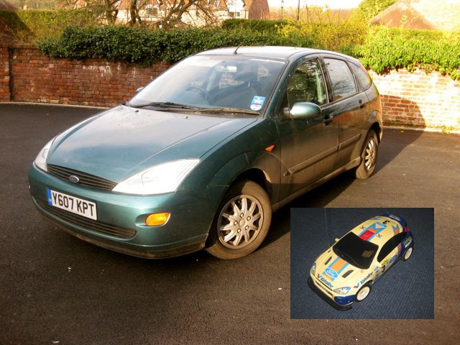Ratio and Scale

The model car is 25 cm long.

The length of the real car is about 5 meters, or 500 cm.

The scale is 25:500, or 1:20

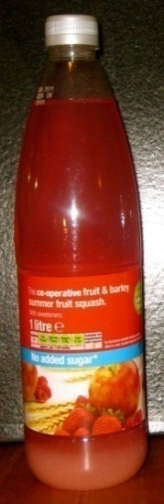

The advice on the juice bottle says mix one part juice to four parts water.

The ratio is 1:4

How much can you make, in total, with one quart of juice?

The ratio of girls to boys is 4:2, which simplifies to 2:1.

The ratio of boys to girls is 1:2

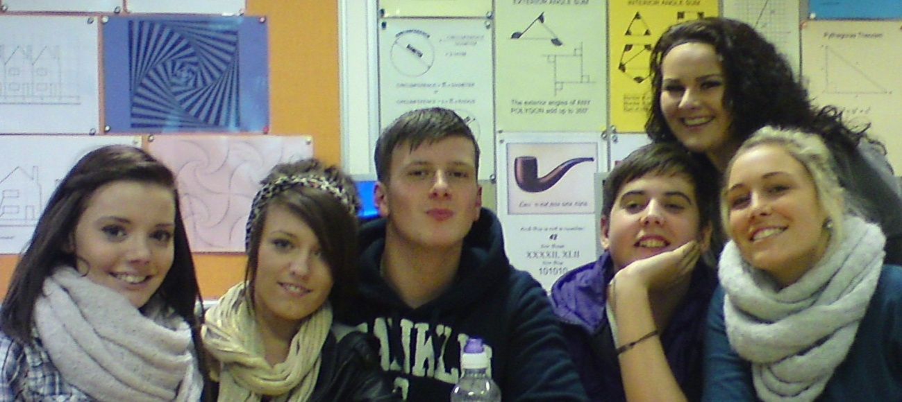

Metric measures

|  |  |  |
| --- | --- | --- |
| **Length** |  |  |
| 10 millimeters | = | 1 centimeter |
| 1000 millimeters | = | 1 meter |
| 100 centimeters | = | 1 meter |
| 1000 meters | = | 1 kilometer |
|  |  |  |
| **Mass** |  |  |
| 1000 grams | = | 1 kilogram |
|  |  |  |
|  |  |  |
| **Capacity** |  |  |
| 1000 milliliters | = | 1 liter |
| 100 centiliters | = | 1 liter |

* Convert between units of measure in the same system

*(NB: Conversion between imperial units will be given.* ***Metric equivalents should be known****)*Imperial/Standard measures

|  |  |  |
| --- | --- | --- |
| **Length** |  |  |
| 12 inches | = | 1 foot |
| 3 feet  5280 feet | =  = | 1 yard  1 mile |
| 1760 yards | = | 1 mile |
|  |  |  |
| **Mass** |  |  |
| 16 ounces  2000 pounds | =  = | 1 pound  1 ton |
|  |  |  |
|  |  |  |
| **Capacity** |  |  |
| 8 ounces | = | 1 cup |
| 2 cups  2 pints  4 quarts | =  =  = | 1 pint  1 quart  1 gallon |

* Convert between units of measure in the same system

*(****NB: Conversion between imperial units will be given.*** *Metric equivalents should be known)*

Know rough metric equivalents of pounds, feet, miles, pints and gallons:

|  |  |  |
| --- | --- | --- |
|  | Metric | Standard |
| kilogram.jpg | 1 kg | 2.2 pounds |
| litre.JPG | 1 *l* | pints |
| gallon.JPG | 4.5 *l* | 1 gallon |
| speedo.JPG | 8 km | 5 miles |
| ft cm 2.JPG | 30 cm | 1 foot |

**Measurements**

‘Recognize that measurements given to the nearest whole unit may be inaccurate by up to one half in either direction.’

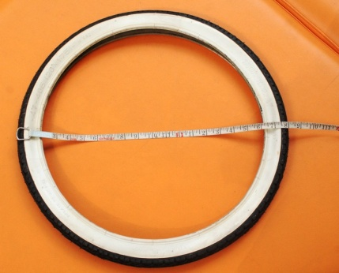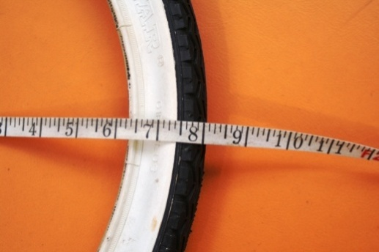

The cycle tire is 1ft 8in, or 20”, measured to the nearest inch.

It could be anything between 1’7½” and 1’8½”, or between 19.5 and 20.5 inches. In centimetres, it is between 49.5 and 50.5 cm.

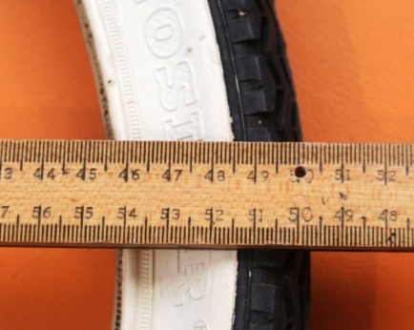

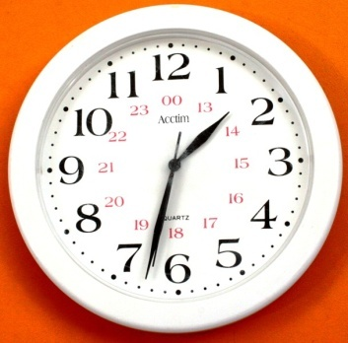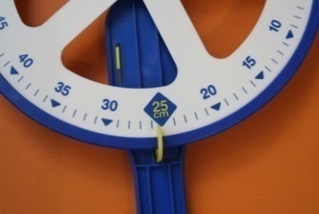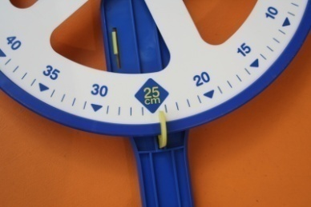

When the clock records 1.32, it is somewhere between 1:31:30 and 1:32:30

The trundle wheel records 25 cm to the nearest whole number – that could be anything between 24.5 and 25.5 cm.

**Finding the nth term of a sequence**

*What is the nth term of the sequence that begins: 7, 11, 15, 19?*

Start with a table, so that you have numbered each term:

|  |  |  |  |  |
| --- | --- | --- | --- | --- |
| Sequence number | 1 | 2 | 3 | 4 |
| Term in the sequence | 7 | 11 | 15 | 19 |

What is the gap? By how much is your sequence going up each time?

In this case the gap is 4, so multiply the sequence number by 4 and see what you get:

|  |  |  |  |  |
| --- | --- | --- | --- | --- |
| Sequence number | 1 | 2 | 3 | 4 |
| Multiply by 4 | 4 | 8 | 12 | 16 |

What do we need to do to our new number to get each term?

|  |  |  |  |  |
| --- | --- | --- | --- | --- |
| Sequence number | 1 | 2 | 3 | 4 |
| Multiply by 4 | 4 | 8 | 12 | 16 |
| Term in the sequence | 7 | 11 | 15 | 19 |

To get from 4→7 we need to add three, and from 8→11 is also add three, and so on.

So our rule is ‘*multiply by 4 and add three*’.

In general terms this could be ‘*n→4n+3*’

|  |  |  |  |  |  |  |  |  |  |  |  |  |  |  |  |  |  |  |  |  |  |  |
| --- | --- | --- | --- | --- | --- | --- | --- | --- | --- | --- | --- | --- | --- | --- | --- | --- | --- | --- | --- | --- | --- | --- |
| 1 |  |  |  |  |  | 2 |  |  |  |  |  |  |  | 3 |  |  |  |  |  |  |  |  |
|  |  |  |  |  |  |  |  |  |  |  |  |  |  |  |  |  |  |  |  |  |  |  |
|  |  |  |  |  |  |  |  |  |  |  |  |  |  |  |  |  |  |  |  |  |  |  |
|  |  |  |  |  |  |  |  |  |  |  |  |  |  |  |  |  |  |  |  |  |  |  |
|  |  |  |  |  |  |  |  |  |  |  |  |  |  |  |  |  |  |  |  |  |  |  |
|  |  |  |  |  |  |  |  |  |  |  |  |  |  |  |  |  |  |  |  |  |  |  |
|  |  |  |  |  |  |  |  |  |  |  |  |  |  |  |  |  |  |  |  |  |  |  |

**Laws of Algebra**

|  |  |  |
| --- | --- | --- |
| **Law** | **Algebraic form** | **Example** |
| **Commutative**  **Law** | *a + b = b + a* | 2 + 5 = 5 + 2 |
|  | *a × b = b × a* | 2 × 5 = 5 × 2 |
| **Associative**  **Law** | *(a + b) + c = a + (b + c)* | (2 + 3) + 4 = 2 + (3 + 4) |
|  | *(a × b) × c = a × (b × c)* | (2 × 3) × 4 = 2 × (3 × 4) |
| **Distributive**  **Law** | *a × (b + c) = (a × b) + (a × c)* | 2 × (4 + 5) = (2 × 4) + (2 × 5) |

**Laws of Indices**

|  |  |  |
| --- | --- | --- |
|  | **Algebraic form** | **Example** |
| **Multiplication** | *xa × xb = xa+b* | 23  25 28 |
| **Division** | *xa ÷ xb = xa-b* | 28  25 23 |
| **Power** | *(xa)b = xab* | (23)5 215 |
| **Negative Indices** | *x-1 = , x-2 =* | 2-1 , 2-2 |
| **Fractional Indices** | *= , =* | , |
| **Zero** | *x0 = 1* | 20 1 |

Cartesian Co-ordinates

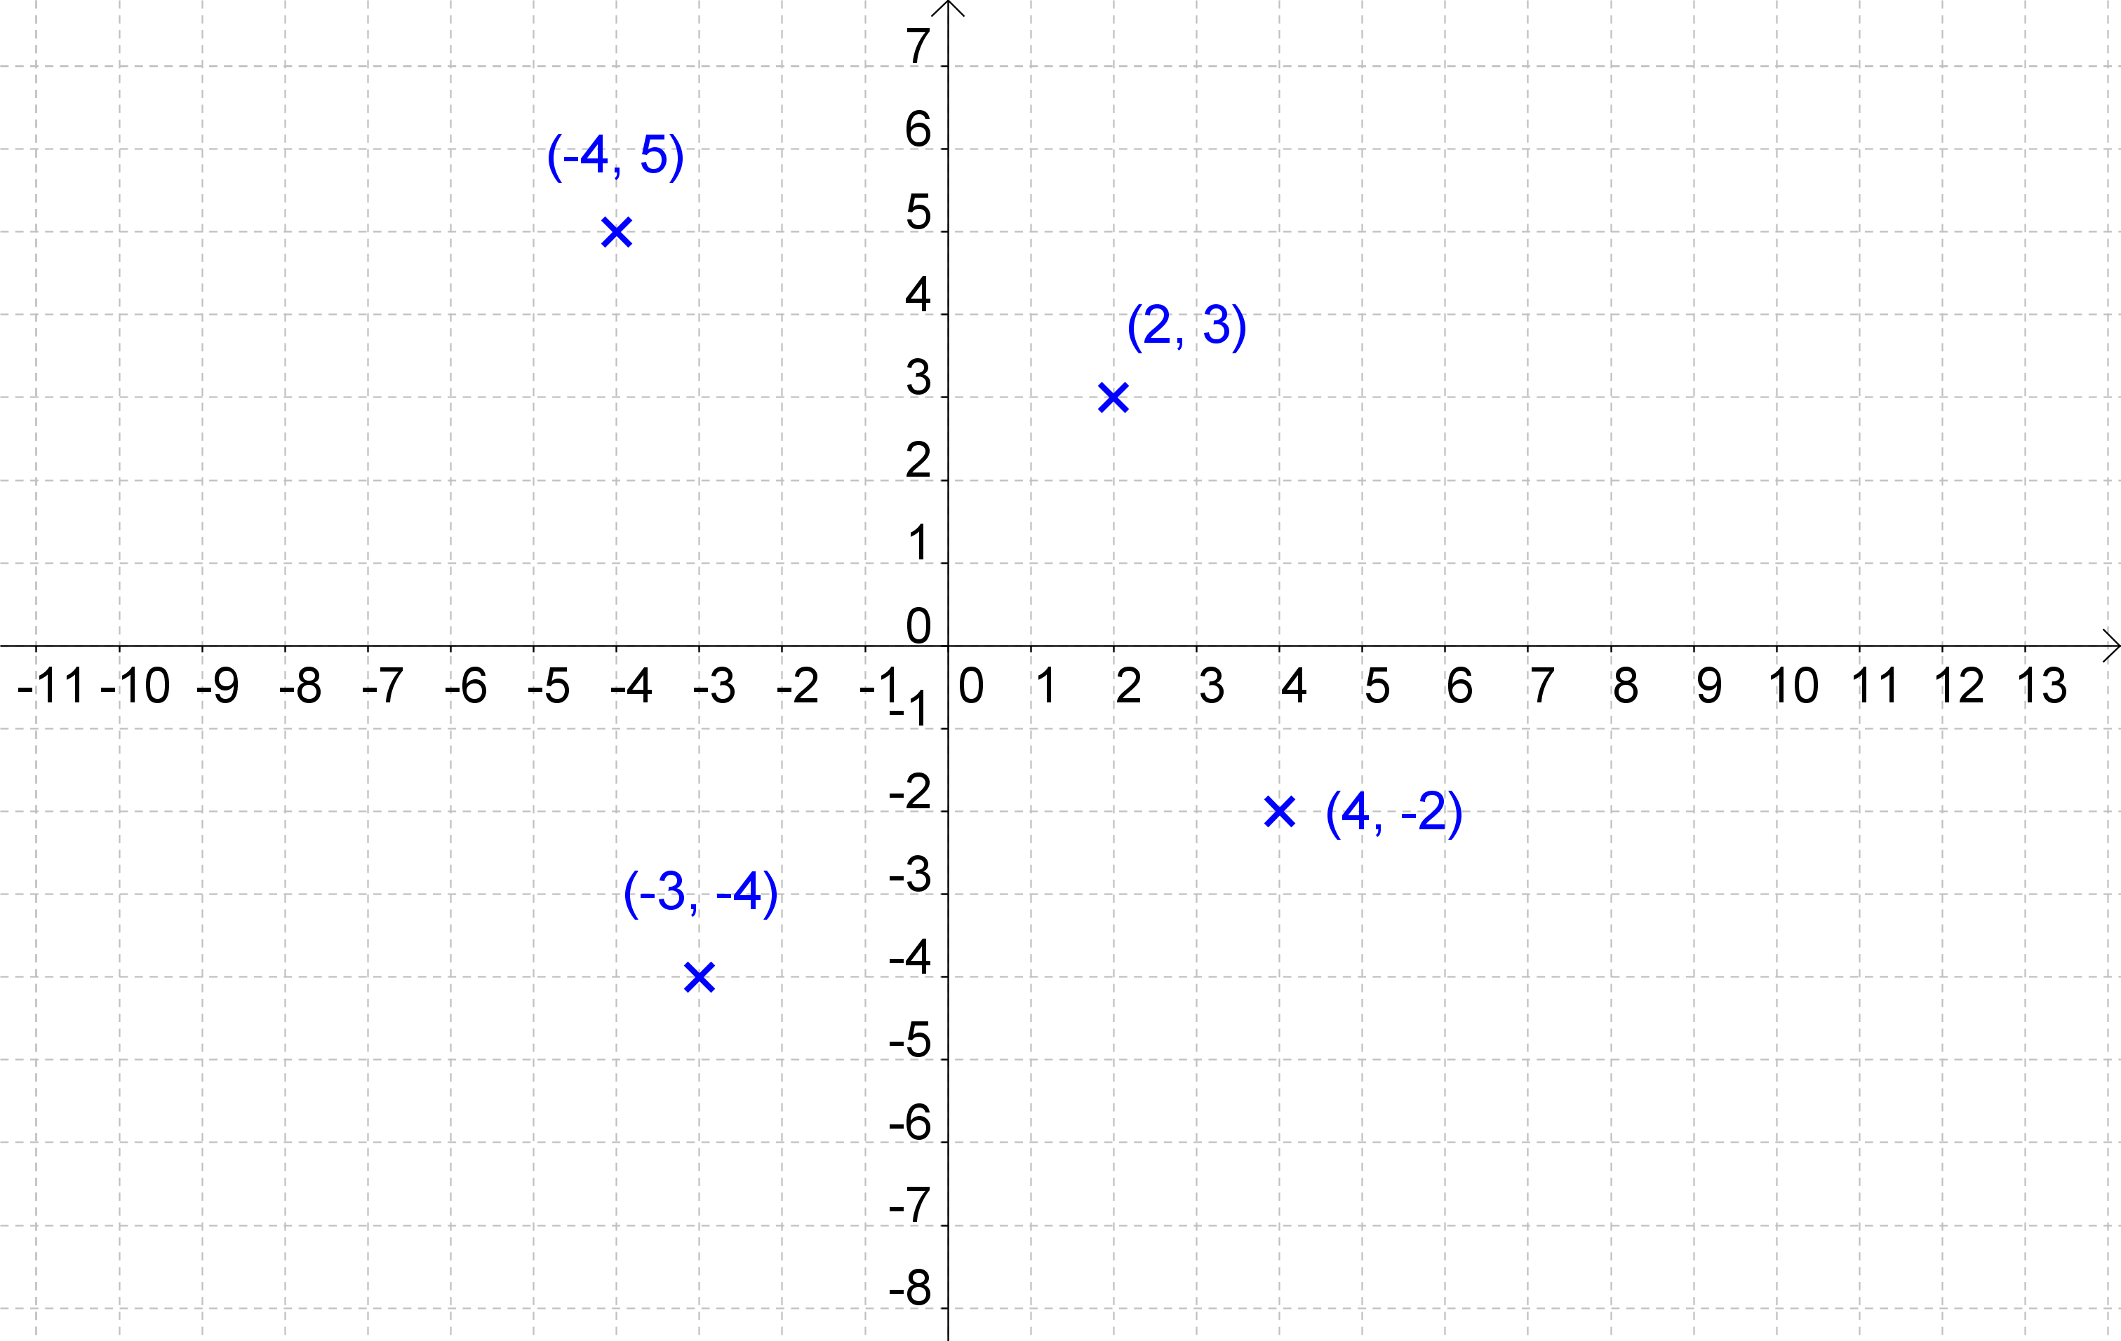

Equation of a line: y = 2x + 3

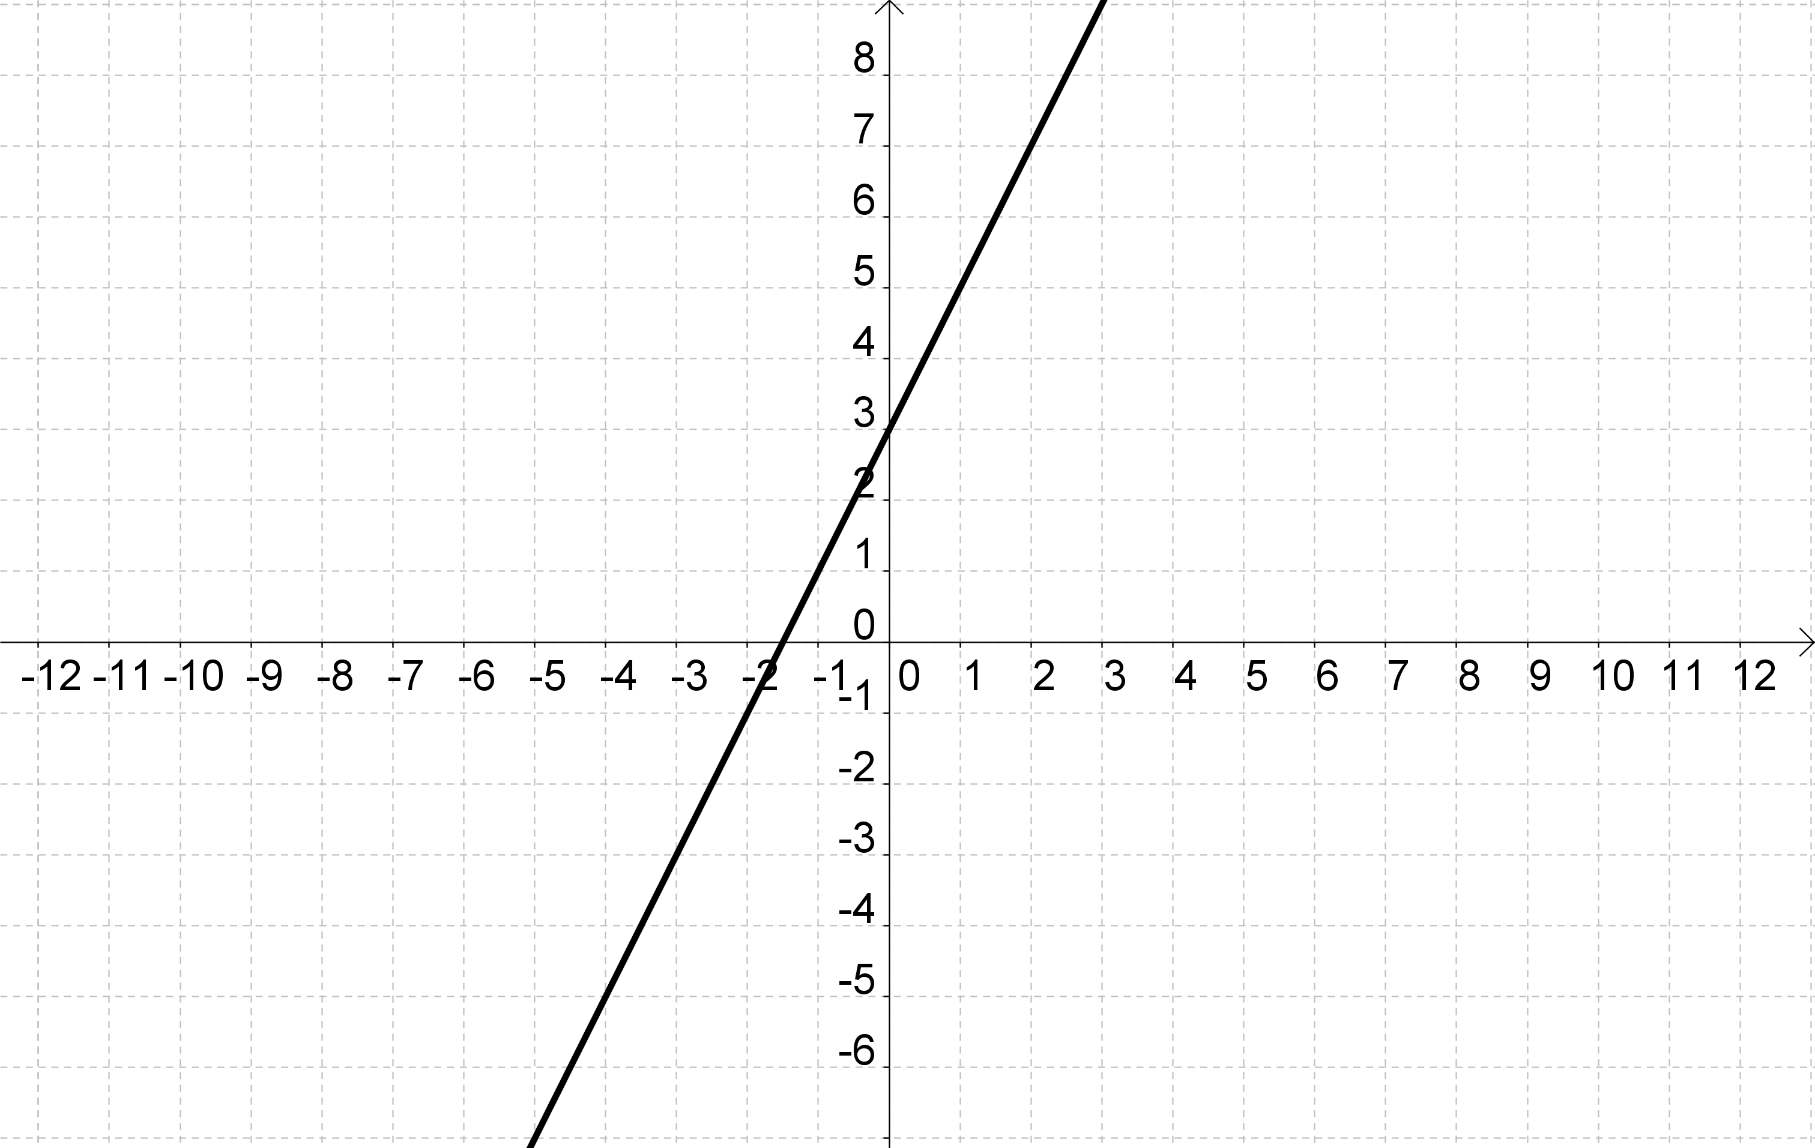



Graphs of Quadratic Equations

y=x2

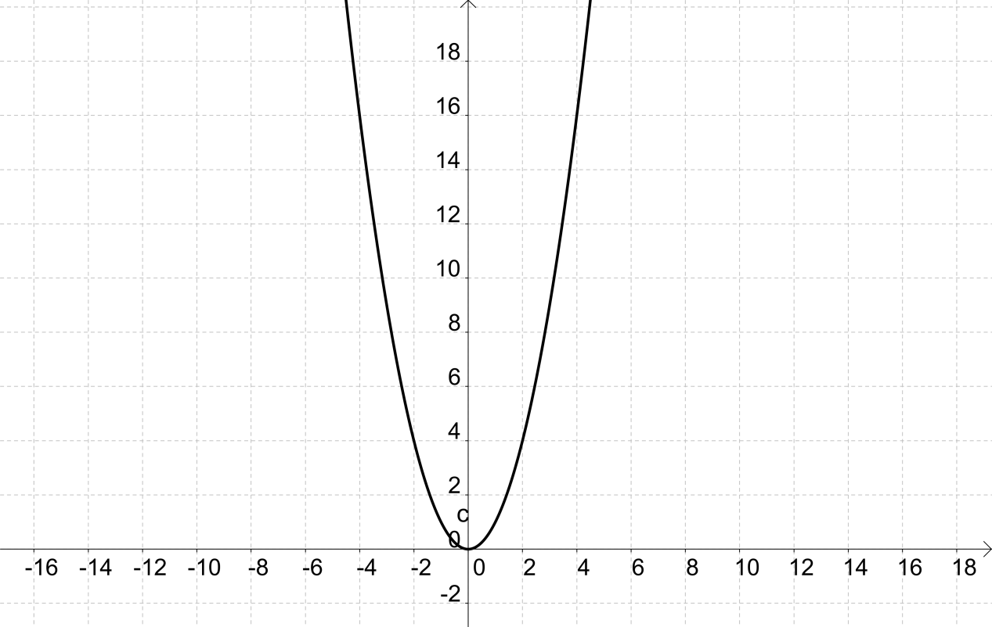

y=x2+5 and y=x2- 5

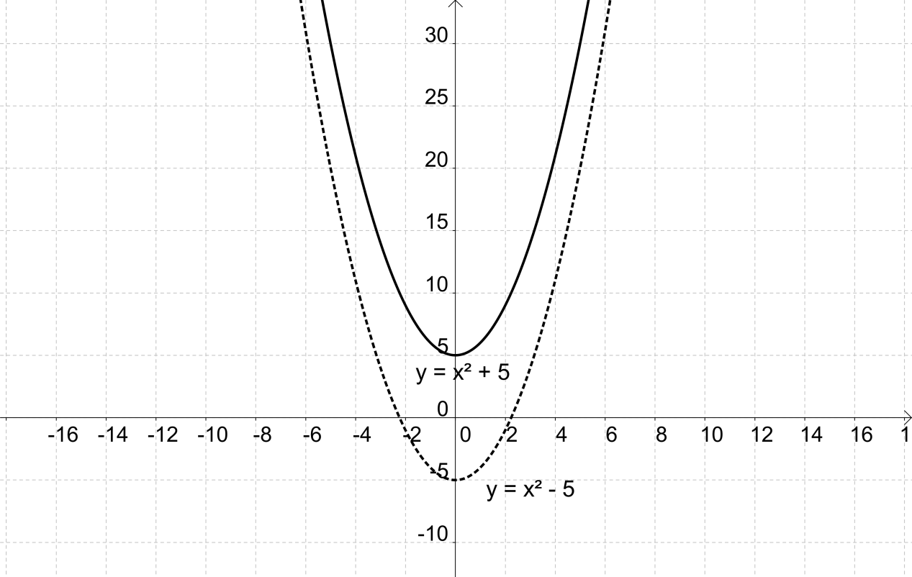

Multiplying simple brackets

y

y(y - 7) = y2 - 7y

y

- 7

y2

- 7y

2x

+ 9

3

6x

+ 27

3(2x + 9) = 6x +27

Multiplying two brackets

x

x

+ 3

+ 2

x2

+ 3x

+ 2x

+ 6

(x + 2)(x + 3) = x2 + 5x + 6

x

a

+ y

+ b

ax

+ ay

+ bx

+ by

(a + b)(x + y)

= ax + bx + ay + by

The Moon and the Smiley Face

(a + b)(x + y)

= ax + ay + bx + by

(a + b)(x + y)

= ax + by + bx + ay

Areas

*A = ½* × *b* × *h*



*a*

*h*

*b*

*A = b* × *h*

*A = l* × *w*

*A = a2*

*h*

*b*

*b*

*h*

*l*

*w*

*a*

CIRCLES

Circumference and Area



π = 3.14159…

circumference = π x diameter

*or*

circumference =2 x π x radius

area = π x r2

*or*

area = π x radius x radius

Angles of Elevation and Angles of Depression

**C**herry Pie’s Delicious

Apple Pies R 2



Types of Angles

Acute angle

Right angle

Obtuse angle

Straight line

Reflex angle

Reflex angle

Obtuse angle

Straight line

Right angle

Acute angle

Angles on a straight line = 1800

Angles at a point = 3600

Vertically Opposite Angles

Alternate Angles

Corresponding Angles

Points and Parallel Lines

***Three figure bearings***

N

A

B

C

70°

250°

***C:\Documents and Settings\TEMP.KIDDERCOLL\Local Settings\Temporary Internet Files\Content.IE5\WOMGGVG4\MC900329238[1].wmf***

C:\Documents and Settings\TEMP.KIDDERCOLL\Local Settings\Temporary Internet Files\Content.IE5\N2DRZS1H\MC900014701[1].wmf

The bearing of B from A is 070°

The bearing of C from A is 250°

*Face north, turn clockwise, and record the angle through which you have turned.*

80°

100°

E

F

The bearing of F from E is 080°

The bearing of E from F is 260°

POLYGONS

INTERIOR ANGLE SUM

|  |  |  |  |  |  |  |
| --- | --- | --- | --- | --- | --- | --- |
| Number of sides | 3 | 4 | 5 | 6 | … | *n* |
| Number of triangles | 1 | 2 | 3 | 4 | … | *(n – 2)* |
| Sum of interior angles | 1800 | 3600 | 5400 | 7200 | … | *(n – 2) x 1800* |

POLYGONS

EXTERIOR ANGLE SUM

The exterior angles of ANY polygon add up to 3600

Similarity

***Definition – Key Stage 2***

Two or more shapes are similar if they have the same shape, but are not necessarily the same size.   
The corresponding sides are in proportion and the corresponding angles are equal.

Congruence

***Definition – Key Stage 2***

Two shapes or solids are congruent if they are identical in every way except for their position; one can be turned into the other by rotation, reflection or translation.

Types of Triangle

**Geometric Proof**

**The sum of the interior angles of a triangle is always 180°.**

**Angle ACD = Angle CAB (x) *Alternate angles***

**Angle BCE = Angle CBA (z) *Alternate angles***

**x + y + z = 180º *(angles on a straight line)***

**Hence the sum of the angles of the triangle = x + y + z = 180º**

A

CX

x

y

*z*

x

*z*

B

D

E

**Exterior angle of a triangle = sum of the interior opposite angles**

A

C

D

B

x

y

z

w

**Angle BCA = 180 – (Angle CAB + Angle CBA)**

***Or z = 180 – (x + y)***

***Angles in a triangle = 180º***

**Angle DCB = 180 – Angle ACB**

***Or w = 180 – z***

***Angles on a straight line = 180º***

**Angle BCD = 180 – [180 – *(x + y)*]**

**Hence Angle BCD = *(x + y)***

Circles

arc

sector

major segment

minor segment

Plans and Perspective Views

Top view

Left side

Front

Prisms

 

Prisms

 



Volume = area of cross section x length

Transformations

translation

reflection

rotation

dilation

Tessellations

Rotational Symmetry

Both types

Line Symmetry

Polygons

***Definition: A plane closed figure whose sides are straight lines.***

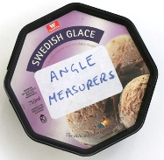

|  |  |
| --- | --- |
| **Number**  **of Sides** | **Name** |
| 3 | Triangle |
| 4 | Quadrilateral |
| 5 | Pentagon |
| 6 | Hexagon |
| 7 | Heptagon |
| 8 | Octagon |
| 9 | Nonagon |
| 10 | Decagon |

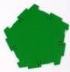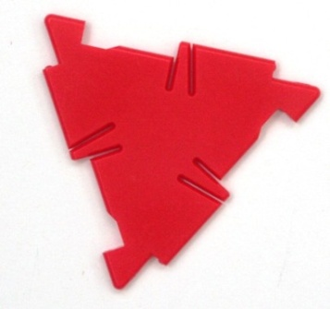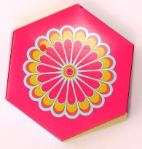

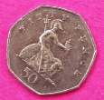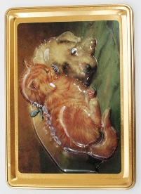

Pythagoras’ theorem

b

c

a

Loci

The square on the hypotenuse is equal to the sum of the squares on the other two sides

a2 + b2 = c2

*or*

**

***Definition***

A set of points satisfying a particular criterion; the criterion is usually to do with their distance from certain fixed points, or the angles they make with other points and lines.

For instance, the locus of points at distance r from fixed point C, is a circle.

C

r

The plural of locus is loci.

B

A

The locus of a point that is a fixed distance r from C

The locus of a point that is equidistant from the points A and B

Travel Graphs or Distance/Time Graphs

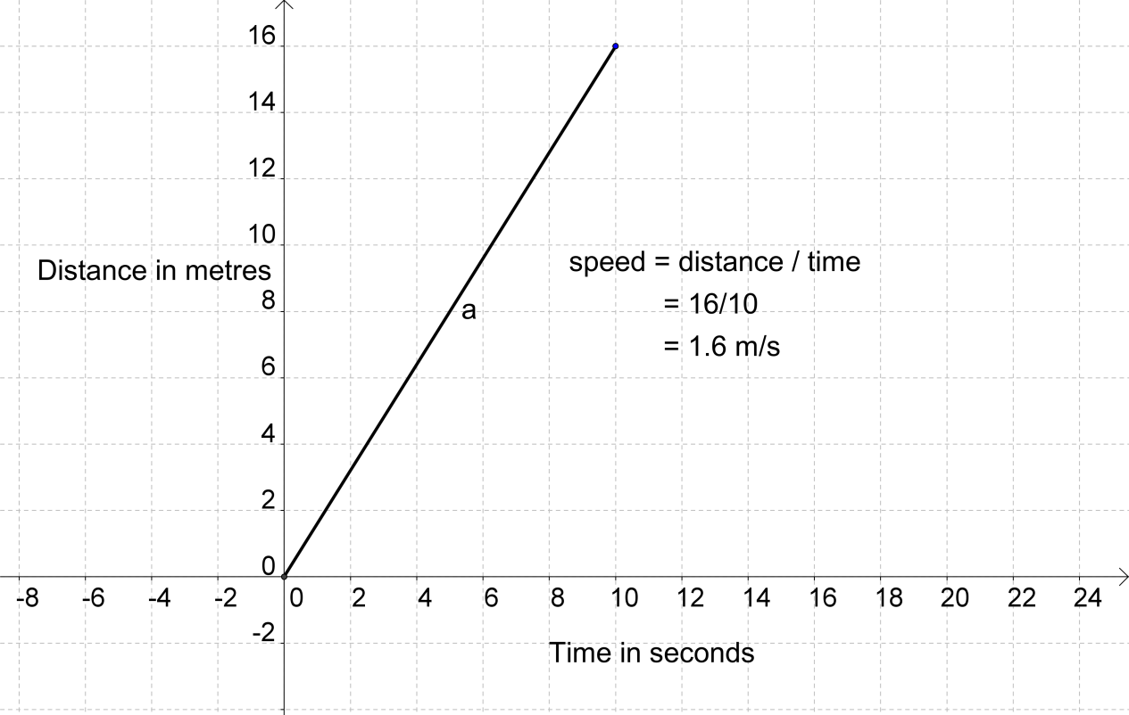

What is happening here?

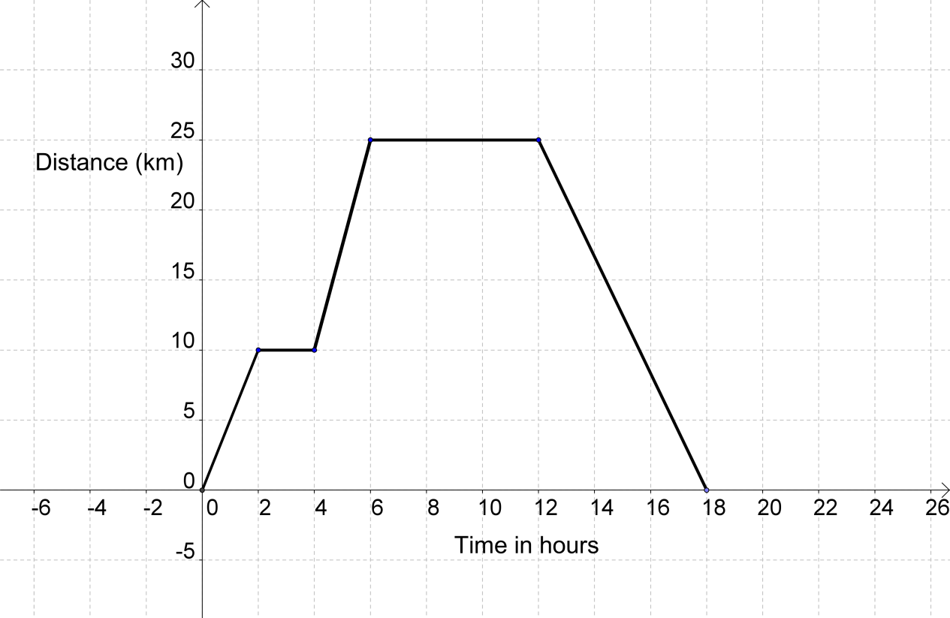

Measures of Central Tendency and Spread

Averages and Range

How many people live in your house?

|  |  |  |  |  |  |  |  |  |  |  |  |  |  |  |
| --- | --- | --- | --- | --- | --- | --- | --- | --- | --- | --- | --- | --- | --- | --- |
| 6 | 2 | 5 | 3 | 1 | 4 | 2 | 3 | 5 | 1 | 7 | 4 | 2 | 2 | 4 |

The MODE

|  |  |  |  |  |  |  |  |  |  |  |  |  |  |  |
| --- | --- | --- | --- | --- | --- | --- | --- | --- | --- | --- | --- | --- | --- | --- |
| 1 | 1 | ***2*** | ***2*** | ***2*** | ***2*** | 3 | 3 | 4 | 4 | 4 | 5 | 5 | 6 | 7 |

The ***mode*** is 2 because that value occurs ***most.***

The MEDIAN

|  |  |  |  |  |  |  |  |  |  |  |  |  |  |  |
| --- | --- | --- | --- | --- | --- | --- | --- | --- | --- | --- | --- | --- | --- | --- |
| 1 | 1 | 2 | 2 | 2 | 2 | 3 | ***3*** | 4 | 4 | 4 | 5 | 5 | 6 | 7 |

The ***median*** is 3 – the value in the ***middle***.

The MEAN

Sum of the values = **51**, Number of values = **15**

|  |  |  |  |  |  |
| --- | --- | --- | --- | --- | --- |
| ***mean*** = | sum of the values | = | **51** | = | **3.4** |
|  | number of values |  | **15** |  |  |

The RANGE

The ***range*** is the difference between

the highest and the lowest:

***range =*** **7 – 1 = 6**

**Stem and Leaf Diagrams**

The ages of one particular group of students:

|  |  |  |  |  |  |  |  |  |  |  |  |
| --- | --- | --- | --- | --- | --- | --- | --- | --- | --- | --- | --- |
| 38 | 21 | 35 | 43 | 35 | 40 | 31 | 20 | 26 | 33 | 39 | 22 |
| 31 | 41 | 39 | 38 | 33 | 24 | 23 | 33 | 24 | 21 | 23 | 33 |
| 44 | 36 | 35 | 35 | 24 | 44 | 24 | 30 | 31 | 23 | 27 | 35 |

First of all, put them into order:

|  |  |  |  |  |  |  |  |  |  |  |  |
| --- | --- | --- | --- | --- | --- | --- | --- | --- | --- | --- | --- |
| 20 | 21 | 21 | 22 | 23 | 23 | 23 | 24 | 24 | 24 | 24 | 26 |
| 27 | 30 | 31 | 31 | 31 | 33 | 33 | 33 | 33 | 35 | 35 | 35 |
| 35 | 35 | 36 | 38 | 38 | 39 | 39 | 40 | 41 | 43 | 44 | 44 |

Then create the Stem and Leaf Diagram

|  |  |
| --- | --- |
|  |  |
| 2 | 0 1 1 2 3 3 3 4 4 4 4 |
| 2 | 6 7 |
| 3 | 0 1 1 1 3 3 3 3 |
| 3 | 5 5 5 5 5 6 8 8 9 9 |
| 4 | 0 1 3 4 4 |

Key: 2⏐0 means 20 years old

*And remember to add a key.*

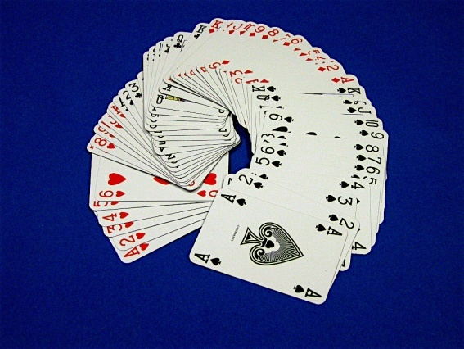Probability

Probability measures how likely an event or outcome is.   
It is usually shown as a success fraction - the number of ways an event could happen compared to the total number of events that could happen - and is written:

|  |  |
| --- | --- |
| **probability(of special event) =** | **(No of times that special event occurs)**  **(Total number of events occurring)** |

A way of measuring the chance that something will happen; if the same experiment is done a very large number of times, the probability of a particular outcome is the proportion of times that it happens.

***it is usually the case that the sum of all probabilities = 1***

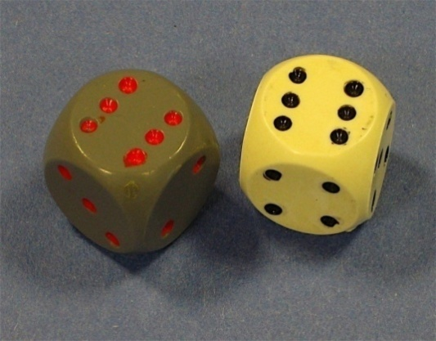

Notes:

|  |
| --- |
|  |
|  |
|  |
|  |
|  |
|  |
|  |
|  |
|  |
|  |
|  |
|  |
|  |
|  |
|  |
|  |
|  |
|  |
|  |
|  |
|  |
|  |
|  |
|  |
|  |
|  |
|  |
|  |
|  |