Calculating methods
Addition

Example 534 + 2678

Place the digits in the correct “place value” columns with the numbers under each other. |  | Th | H | T | O
Begin adding in the ones column. |  |  | 5 | 3 | 4
Show any carrying in the next column. | + | ₁2 | ₁6 | ₁7 | 8
 |  | 3 | 2 | 1 | 2

Subtraction

Example: 7689 - 749

Place the digits in the correct “place value” columns with the numbers under each other. |  | Th | H | T | O
Begin subtracting in the ones column. |  | ⁶7 | ¹6 | ⁷8 | ¹6
You can’t subtract 9 from 6 so move 1 ten from  the 8 tens to the 6 ones to make 16 ones. | - |  | 7 | 4 | 9
 |  | 6 | 9 | 3 | 7
Note that the same has happened with the hundreds.

Multiplication

Example 56 x 34

Separate the 56 and 34 into tens and ones. |  |  | x | 50 | 6
Multiply the columns with the rows and place the answers in the grey boxes. |  |  | 30 | 1500 | 180
 |  |  | 4 | 200 | 24
Add the numbers: 1500 + 180 + 200 + 24
= 1904

Division

Example: 432 ÷ 15

Long division method

 |  | 2 | 8 |  | 4 is not divisible by 15, so you divide 43 by 15.
15 | 4 | 3 | 2 |  | 3 x 15 = 45 which is more than 43 so choose 2 x 15 = 30.
 | 3 | 0 | ↓ |  | Subtract 30 from 43 to give a remainder of 13.
 | 1 | 3 | 2 |  | Bring the 2 down in order to make 132.
 | 1 | 2 | 0 |  | 8 x 15 = 120.
 |  | 1 | 2 |  | Subtract 120 from 132 to give a remainder of 12.
 |  |  |  |  | There are no more numbers to bring down, therefore, the answer is:
28 r 12 |  |  |  |  | 28 with a remainder of 12.

Concise method

 |  |  |  |  |  | 4 is not divisible by 15, so you divide 43 by 15.
 |  | 2 | 8 | r12 |  | 3 x 15 = 45 which is more than 43 so choose  2 x 15 = 30.
15 | 4 | 3 | ¹³2
 |  |  |  |  |  | Subtract 30 from 43 to give a remainder of 13.
 |  |  |  |  |  | Write 13 in front of the 2 to give 132.
 |  |  |  |  |  | 8 x 15 = 120.
 |  |  |  |  |  | Subtract 120 from 132 to give a remainder of 12. Therefore, the answer is: 28 r 12

Division without tears!

x | 15 | Sum |  | We use the 10, 5, 2 and 1 tables which are easier.
10 | 150 | 150 |  | 10 x 15 = 150 which is a great deal less than 432.
10 | 150 | 300 |  | Another 10 x 15 will make a total of 300.
5 | 75 | 375 |  | Another 10 x 15 will give a total of 450 which is more than 432 so we use 5 x 15 = 75 giving a total of 375.
2 | 30 | 405 |  | 5 x 15 is too big, so use 2 x 15 = 30 gives 405.
1 | 15 | 420 |  | 2 x 15 is too big, so use 1 x 15 = 15 to give 420.
28 |  | r12 |  | 1 x 15 is too big, therefore, the remainder is  432 – 420 = 12.
 |  |  |  | By adding the “x” column we can see how many 15s there are in 432. Answer: 10 + 10 + 5 + 2 + 1 = 28.

Even numbers Square numbers

2, 4, 6, 8, 10, 12, ………… 1² = 1 x 1 = 1
2 divides exactly into every even number. 2² = 2 x 2 = 4
3² = 3 x 3 = 9
Odd numbers 4² = 4 X 4 = 16
5² = 5 X 5 = 25
1, 3, 5, 7, 11, ………… 6² = 6 x 6 = 36
2 doesn’t divide exactly into odd numbers. 7² = 7 x 7 = 49

The first 7 square numbers
are: 1, 4, 9, 16, 25, 36, 49

Triangular numbers Factors
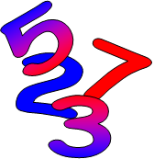
1 = 1 A factor is a number that
1 + 2 = 3 divides exactly into another
1 + 2 + 3 = 6 number.
1 + 2 + 3 + 4 = 10 The factors of 12 are:
1 + 2 + 3 + 4 + 5 = 15 1, 2, 3 ,4, 6, 12
1 + 2 + 3 + 4 + 5 + 6 = 21
1 + 2 + 3 + 4 + 5 + 6 + 7 = 28 The factors of 13 are 1 and 13

The first seven triangular numbers are:
1, 3, 6, 10, 15, 21, 28

Prime numbers

A prime number has exactly two
factors namely 1 and itself.

The factors of 17 are 1 and 17,
therefore 17 is a prime number.

The prime numbers between 1 and 100
are:

2, 3, 5, 7, 11, 13, 17, 19, 23,
29, 31, 37, 41, 43, 47, 53, 59, 61,
67, 71, 73, 79, 83, 89, 97
Note: 1 is not a prime number!
Place value

Thousands  (1000) | Hundreds  (100) | Tens  (10) | Ones  (1) | . | Tenths  1  10 | Hundredths  1  100 | Thousandths  1  1000

10 ones | = | 1 ten | 10 thousandths | = | 1 hundredth
10 tens | = | 1 hundred | 10 hundredths | = | 1 tenth
10 hundreds | = | 1 thousand | 10 tenths | = | 1 unit

The placement of the digits within the number gives us the value of that digit.

The digit 4 has the value of The digit 5 has the value
4 thousand of 5 tenths ( ⁵/₁₀ )
4 2 8 4 . 5 6 7
(4000)

The digit 8 has the value The digit 7 has the value
8 tens (80) 7 thousandths ( ⁷/₁₀₀₀ )

Inverse operations

Inverse operations allow you to undo a sum.

 | Operator |  | Inverse Operation
 | + |  | –
 | – |  | +
 | ÷ |  | x
 | x |  | ÷

We use inverse operations when we work with function machines.

Input | ? | → | ÷ 3 | → | – 7 | = | 3 | Output
If the output is 3, the input ? must be 30. | 30 | = | x 3 | ← | + 7 | ← | 3

Fractions

The numerator is the number

3
4

on the top of the
fraction

The denominator is the
number on the bottom

If we have a number and a fraction mixed we call it a mixed fraction. | 3 | 7
 |  | 8

When the numerator is larger than the denominator we call this an improper fraction. | 9
 | 7

Equivalent fractions

All the fractions below represent the same proportion. Therefore they are called equivalent fractions.

¹/₂ |  |  | ²/₄ |  |  | ⁴/₈

1 | = | 2 | = | 3 | = | 4 | = | 5 | = | . . . .
2 |  | 4 |  | 6 |  | 8 |  | 10
1 | = | 2 | = | 3 | = | 4 | = | 5 | = | . . . .
3 |  | 6 |  | 9 |  | 12 |  | 15
 |  |  |  |  |  |  |  |  |  | etc.
1 | = | 2 | = | 3 | = | 4 | = | 5 | = | . . . .
4 |  | 8 |  | 12 |  | 16 |  | 20
3 | = | 6 | = | 9 | = | 12 | = | 15 | = | . . . .
4 |  | 8 |  | 12 |  | 16 |  | 20

Decimals

A decimal is any number that contains a decimal point.
The following are examples of decimals.

0⋅549 1⋅25 256⋅4 3⋅406

Percentages

 | The symbol | % | means | 1
 |  |  |  | 100

 | 7% | means | ⁷/₁₀₀
 | 63% | means | ⁶³/₁₀₀
 | 100% | means | ¹⁰⁰/₁₀₀ | or 1 whole.
 | 120% | means | ¹²⁰/₁₀₀ | It is possible to have a percentage that is greater than 1 whole.

Changing decimals and fractions into percentages
To change a decimal or fraction to a percentage you have to multiply with 100%.

0⋅75 x 100% = 75%

13 x ⁵100% = 65%
₁20

To change a fraction into a decimal you have to divide the numerator with the denominator.

3 = 3 ÷ 8 = 0⋅375
8

It is also possible to change a fraction into a percentage like this:

2 = 2 ÷ 3 = 0⋅6666 . . . = 0⋅67 ( to 2 decimal places )
3

then 0⋅67 x 100% = 67%

Therefore 2/3 = 67% ( to the nearest one part of a hundred )

Useful fractions, decimals and percentages

Fraction |  | Decimal |  | Percentage
 | 1 |  | 1⋅0 | 100%
 | ¹/₂ |  | 0⋅5 | 50%
 | ¹/₃ |  | 0⋅33..... | 33%
 | ¹/₄ |  | 0⋅25 | 25%
 | ³/₄ |  | 0⋅75 | 75%
 | ¹/₁₀ |  | 0⋅1 | 10%
 | ²/₁₀ ( = ¹/₅ ) |  | 0⋅2 | 20%
 | ³/₁₀ |  | 0⋅3 | 30%

Ratio

Ratio is used to make a comparison between two things.

Example

In this pattern we can see that there are 3 happy faces to every sad face.
We use the symbol : to represent to in the above statement, therefore we write the ratio like this:

Happy | : | Sad | Sad | : | Happy
3 | : | 1 | 1 | : | 3
Ratio is used in a number of situations:

- In a cooking recipe
- In building when mixing concrete
- It is used in the scale of maps
e.g. if a scale of 1 : 100 000 is used,
it means that 1 cm on the map represents
100 000 cm in reality which is 1 km.

Integers / Directed numbers

The negative sign ( - ) tells us the number is below zero e.g. -4. The number line is useful when working with negative numbers. Below is a part of the number line.

Negative direction ← |  |  |  |  |  |  |  |  |  | → Positive direction
-9 | -8 | -7 | -6 | -5 | -4 | -3 | -2 | -1 | 0 | 1 | 2 | 3 | 4 | 5 | 6

The numbers on the right are greater than the numbers on the left e.g. 5 is greater than 2 and 2 is greater than -3. Note that -3 is greater than -8.

Adding and subtracting integers

The Number line game can be used to add and subtract negative numbers:

Rules:
Start at zero facing the positive direction.
Ignore any + signs.
The – sign means “make half a turn” .
When you see a number, step the value of the number in the direction you are facing.
After stepping, face the positive direction before continuing with the sum.
Your position at the end will be the answer.
Example: – 3 – 4 + 6

Sum | -8 | -7 | -6 | -5 | -4 | -3 | -2 | -1 | 0 | 1 | Method
 |  |  |  |  |  |  |  |  | → |  | Start at zero.
- |  |  |  |  |  |  |  |  | ← |  | Make half a turn.
3 |  |  |  |  |  | ← |  |  |  |  | Step 3.
 |  |  |  |  |  | → |  |  |  |  | Face the positive.
- |  |  |  |  |  | ← |  |  |  |  | Make half a turn.
4 |  | ← |  |  |  |  |  |  |  |  | Step 4.
 |  | → |  |  |  |  |  |  |  |  | Face the positive.
+ |  | → |  |  |  |  |  |  |  |  | Ignore the +.
6 |  |  |  |  |  |  |  | → |  |  | Step 6.
 |  |  |  |  |  |  |  |  |  |  | The answer is -1.

Example: 2 + – 8 – – 9

 |  |  | • |  |  |  |  |  | • |  | • | •
-9 | -8 | -7 | -6 | -5 | -4 | -3 | -2 | -1 | 0 | 1 | 2 | 3 | 4 | 5 | 6

• Start at zero facing the positive direction.
• Step 2 and face the positive direction.
• Ignore the + , make half a turn, step 8 and face the positive direction.
• Make half a turn, make half a turn, step 9 and note your position.
The answer is 3 :

Multiplying and dividing integers

We multiply and divide directed numbers in the usual way while remembering these very important rules:

Two signs the same, a positive answer.
Two different signs, a negative answer.

× | + | - |  | ÷ | + | -
+ | + | - |  | + | + | -
- | - | + |  | - | - | +

Remember, if there is no sign before the number, it is positive.

Examples:

5 | x | -7 | = | -35 |  | (different signs give a negative answer)
-4 | x | -8 | = | 32 |  | (two signs the same give a positive answer)
48 | ÷ | -6 | = | -8 |  | (different signs give a negative answer)
-120 | ÷ | -10 | = | 12 |  | (two signs the same give a positive answer)

Coordinates

We use coordinates to describe location.
0
1
2
3
-3
-2
-1
3
2
1
-1
-2
-3
A
B
C
D
x
y
The coordinates of the points are:

A(1,2) B(-2,3) C(-2,-2) D(3,-2)

There is a special name for the point (0,0) which is the origin.

The first number (x-coordinate) represents the distance across from the origin.
The second number (y-coordinate) represents the distance going up or down.

Example : The point (1,2) is one across and two up from the origin.

Inequalities

We us the = sign to show that two sums are equal. If one sum is greater than or less than the other we use inequalities:

< less than > more than

< less than or equal to > more than or equal to

Examples :

5 < 8 43 > 6 x < 8 y > 17

Names of two dimensional shapes

A polygon is a closed shape made up of straight lines.
A regular polygon has equal sides and equal angles.

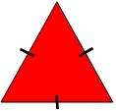 |  |  |  | 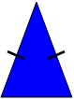
Equilateral triangle |  | Right angled triangle |  | Isosceles triangle
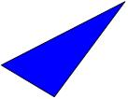
Scalene triangle |  | Square |  | Rectangle
Parallelogram |  | Rhombus |  | Trapezoid
Opposite sides parallel and equal. |  | Opposite sides parallel, all sides equal. |  | One pair of opposite sides parallel.
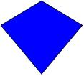 |  | 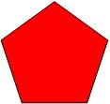 |  | 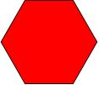
Kite |  | Pentagon |  | Hexagon
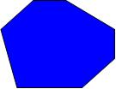 |  | 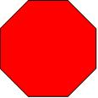
Heptagon |  | Octagon |  | Circle

3D shapes

3D means three dimensions – 3D shapes have length, width and height.

Shape | Name | Faces | Edges | Vertices (corners)
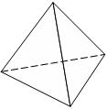 | Triangular Pyramid | 4 | 6 | 4
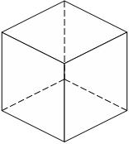 | Cube | 6 | 12 | 8
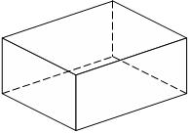 | Rectangular Prism | 6 | 12 | 8
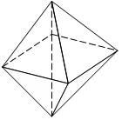 | Octahedron | 8 | 12 | 6
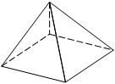 | Square  pyramid | 5 | 8 | 5
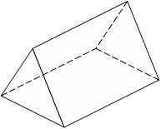 | Triangular prism | 5 | 9 | 6

Euler’s formula:

Number of faces - Number of edges + Number of vertices = 2

The circle
Center
Diameter
Radius
Chord
Tangent
Circumference

Circumference of a circle

The circumference of a circle is the distance around the circle.

Circumference = π x diameter
Circumference = πd

Since the diameter is twice the length of the radius, we can also write

Circumference = π x 2 x radius
Circumference = 2πr

π (pi)

π is a Greek letter which represents 3•1415926535897932384 . . . . . (a decimal that carries on for ever without repetition)

We round π to 3•14 in order to make calculations or we use the π button on the calculator.
Perimeter

Perimeter is the distance around the outside of a shape. We measure the perimeter in millimeters (mm), centimeters (cm), meters (m), etc.
This shape has been drawn on a 1cm grid. Starting on the orange circle and moving in a clockwise direction, the distance travelled is . . .

1 + 1 + 1 + 1 + 1 + 1 + 1 + 1 + 1 + 2 + 1 + 2 = 14cm

Perimeter = 14cm
Area of 2D Shapes

The area of a shape is how much surface it covers. We measure area in square units e.g. centimeters squared (cm²) or meters squared (m²).

Areas of irregular shapes

Given an irregular shape, we estimate its area through drawing a grid and counting the squares that cover the shape.

Whole square –
count as one.
Half a square or more –
count as one.
Less than half a square - ignore.
1
5
6
11
2
3
10
9
8
4
7
Area = 11cm².

Remember that this is an estimate and not the exact area.

Area formula

Rectangle |  |  |  | Triangle
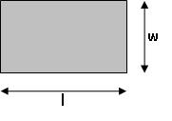 |  |  |  | 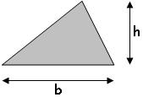
Multiply the length with the width. |  |  |  | Multiply the base with the height and divide by two.
Area = | l x w |  |  | Area = | b x h
 |  |  |  |  | 2
Trapezoid |  |  |  | Parallelogram
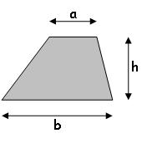 |  |  |  | 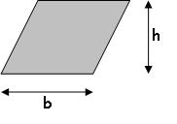
Add the parallel sides, multiply with the height and divide by two. |  |  |  | Multiply the base with the height.
Area = | (a + b) h |  |  | Area = | b x h
 | 2
Circle
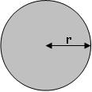
Multiply the radius with itself, then multiply with π.
Area = | r x r x π = πr²

Volume
Volume is the amount of space that an object contains or takes up. The object can be a solid, liquid or gas.

Volume is measured in cubic units e.g. cubic centimeters (cm³) and cubic meters (m³).

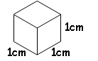

Rectangular Prism

Note that a rectangular prism has six rectangular faces.

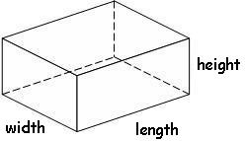 |  | Volume rect. prism= length x width x height

Prism

A prism is a 3-dimensional object that has the same shape throughout its length
i.e. it has a uniform cross-section.

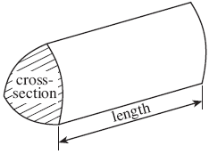 |  | Volume of a prism = area of the base x length

Metric units of length
Millimeter |  | mm |  |  |  | 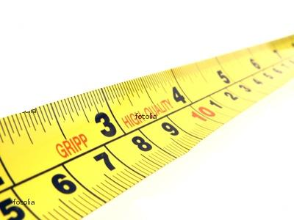  10 mm = 1 cm 1 000 mm = 1 m
Centimeter |  | cm |  |  |  | 100 cm = 1 m 100 000 cm = 1 km
Meter |  | m |  |  |  | 1 000 m = 1 km
Kilometer |  | km

Imperial/Standard units of length
Inch |  | in or ” |  |  |  | 12 in = 1 ft
Foot |  | ft or ’ |  |  |  | 3 ft = 1 yd
Yard |  | yd |  |  |  | 1 760 yd = 1 mile
Mile

Metric units of mass
Milligram |  | mg |  |  |  | 1 000 mg = 1 g 1 000 000 mg = 1 kg
Gram |  | g |  |  |  | 1 000 g = 1 kg
Kilogram |  | kg |  |  |  | 1 000 kg = 1 t
Metric ton |  | t |  |  |  | 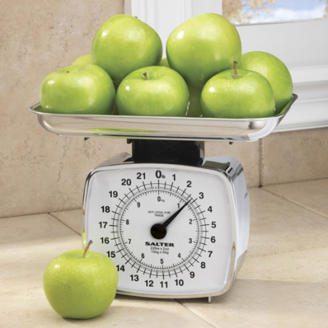

Imperial/Standard units of mass
Ounce |  | oz |  |  |  | 16 oz = 1 lb
Pound |  | lb |  |  |  | 2000 lb = 1 ton
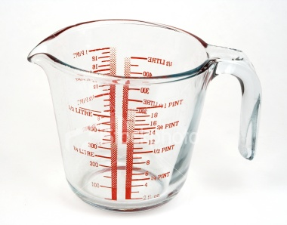
Metric units of volume
Milliliter |  | ml |  |  |  | 1 000 ml = 1 l
Liter |  | l

Imperial/Standard units of volume
Ounce oz  Cup c  Pint | pt |  |  |  | 8 oz = 1 c
Quart qt  Gallon | gal |  |  |  | 4 qt = 1 gal

Converting between imperial and metric units

Length
1 inch | ≈ | 2.5 cm
1 foot | ≈ | 30 cm
1 mile | ≈ | 1.6 km
5 miles | ≈ | 8 km
Weight/Mass
1 pound | ~ | 454 g
2.2 pounds | ~ | 1 kg
1 ton | ~ | 1 metric tonne
Volume
1 gallon | ≈ | 4.5 litre
1 pint | ≈ | 0.6 litre(568 ml)
1¾ pints | ≈ | 1 litre

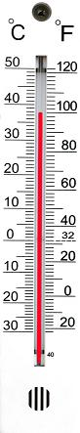

Temperature

Converting from Celsius (°C) to Fahrenheit (°F)
Use the following formula
F = 1.8 x C + 32
Converting from Fahrenheit (°F) to Celsius (°C)
Use the following formula
C = (F – 32) ÷ 1.8

Look at the thermometer:

The freezing point of water is 0°C or 32°F
Time

1000 | years | = | 1 millennium
100 | years | = | 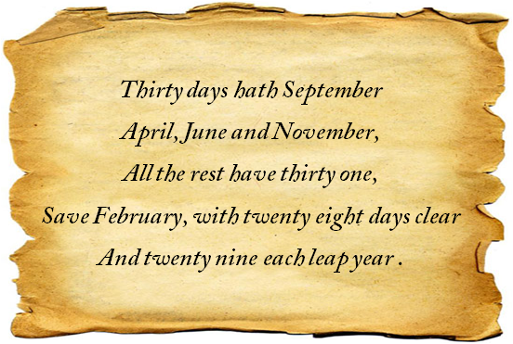  1 century
10 | years | = | 1 decade
60 | seconds | = | 1 minute
60 | minutes | = | 1 hour
24 | hours | = | 1 day
7 | days | = | 1 week
12 | months | = | 1 year
52 | weeks | ≈ | 1 year
365 | days | ≈ | 1 year
366 | days | ≈ | 1 leap year

The Yearly Cycle

Season | Month | 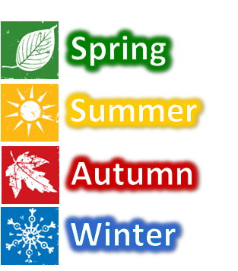  Days
 | January | 31
 | February | 28
 | March | 31
 | April | 30
 | May | 31
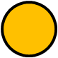 | June | 30
 | July | 31
 | August | 31
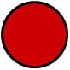 | September | 30
 | October | 31
 | November | 30
 | December | 31

The 24 hour and 12 hour clock

 | 24 hour |  | 12 hour
Midnight | 00:00 |  | 12.00 a.m. | Midnight
The 24 hour clock always uses 4 digits to show the time.  The 24 hour system does not use a.m. nor p.m. | 01:00 |  | 1:00 a.m. | The 12 hour clock shows the time with a.m. before mid-day and p.m. after mid-day.
 | 02:00 |  | 2:00 a.m.
 | 03:00 |  | 3:00 a.m.
 | 04:00 |  | 4.00 a.m.
 | 05:00 |  | 5:00 a.m.
 | 06:00 |  | 6:00 a.m.
 | 07:00 |  | 7:00 a.m.
 | 08:00 |  | 8:00 a.m.
 | 09:00 |  | 9:00 a.m.
 | 10:00 |  | 10:00 a.m.
 | 11:00 |  | 11:00 a.m.
Mid-day | 12:00 |  | 12:00 p.m. | Mid-day
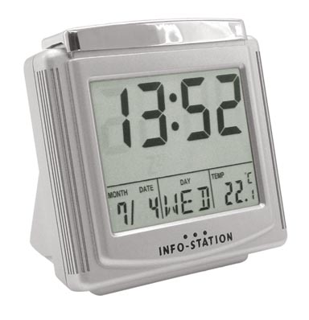 | 13:00 |  | 1:00 p.m. | 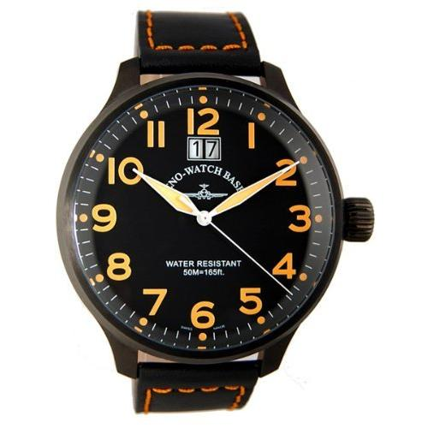
 | 14:00 |  | 2:00 p.m.
 | 15:00 |  | 3:00 p.m.
 | 16:00 |  | 4:00 p.m.
 | 17:00 |  | 5:00 p.m.
 | 18:00 |  | 6:00 p.m.
 | 19:00 |  | 7:00 p.m.
 | 20:00 |  | 8:00 p.m.
 | 21:00 |  | 9.00 p.m.
 | 22:00 |  | 10.00 p.m.
 | 23:00 |  | 11:00 p.m.

Time vocabulary

02:10 | Ten past two in the morning | 2:10 a.m.
07:15 | Quarter past seven in the morning | 7:15 a.m.
15:20 | Twenty past three in the afternoon | 3:20 p.m.
21:30 | Half past nine in the evening | 9:30 p.m.
14:40 | Twenty to three in the afternoon | 2:40 p.m.
21:45 | Quarter to ten at night | 9:45 p.m.

Bearings

A bearing describes direction. A compass is used to find and follow a bearing.

The diagram below shows the main compass points and their bearings.

NE
N
SW
NW
SE
W
S
E
000°
045°
315°
270°
225°
135°
180°
N – North, S – South, E – East, W - West
090°

The bearing is an angle measured clockwise from the North.

Bearings are always written using three figures e.g. if the angle from the North is 5°, we write 005°.
Data

We collect data in order to highlight information to be interpreted.

There are two types of data:

Discrete data  Things that are not measured: | Continuous data  Things that are measured:
- Colors  - Days of the week  - Favorite drink  - Number of boys in a family  - Shoe size | - Pupil height  - Volume of a bottle  - Mass of a chocolate bar  - Time to complete a test  - Area of a television screen

Discrete data

Collecting and recording

We can record data in a list
e.g. here are the numbers of pets owned by pupils in form 9C:
1 , 2 , 1 , 1 , 2 , 3 , 2 , 1 , 2 , 1 , 1 , 2 , 4 , 2 , 1 , 5 , 2 , 3 , 1 , 1 , 4 , 10 , 3 , 2 , 5 , 1
A frequency table is more structured and helps with processing the information.
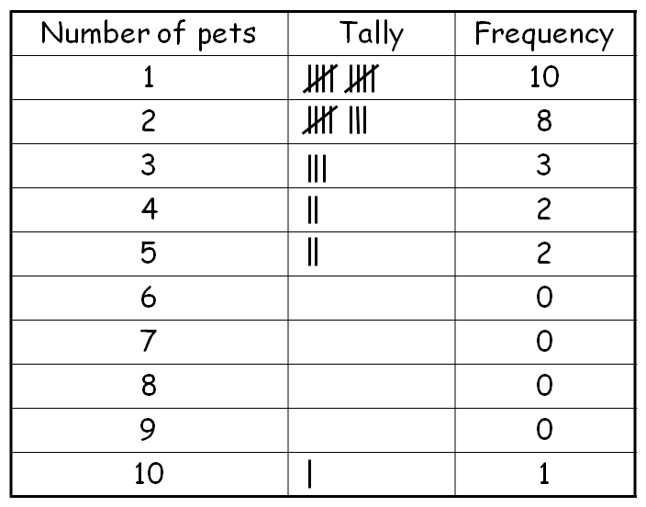

Displaying
In order to communicate information, we use statistical diagrams. Here are some examples:

Pictogram
A pictogram uses symbols to represent frequency. We include a key to show the value of each symbol.

The diagram below shows the number of pets owned by pupils in 9C.
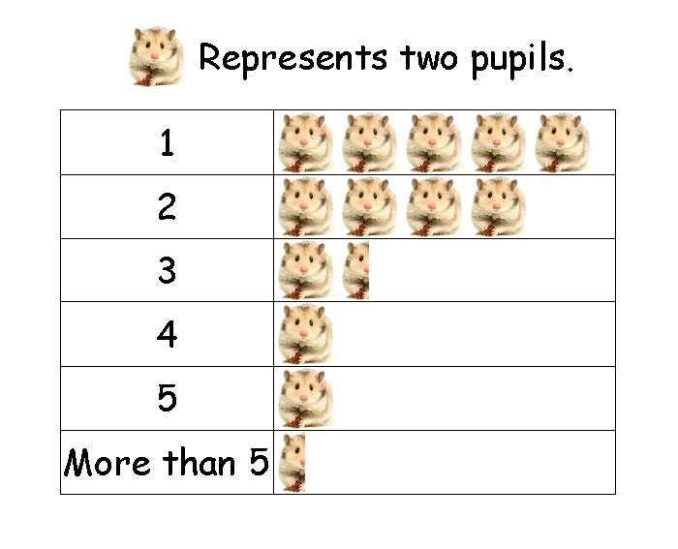

Bar chart
The height of each bar represents the frequency. All bars must be the same width and have a constant space between them. Notice that the scale of the frequency is constant and starts from 0 every time. Remember to label the axes and give the chart a sensible title.
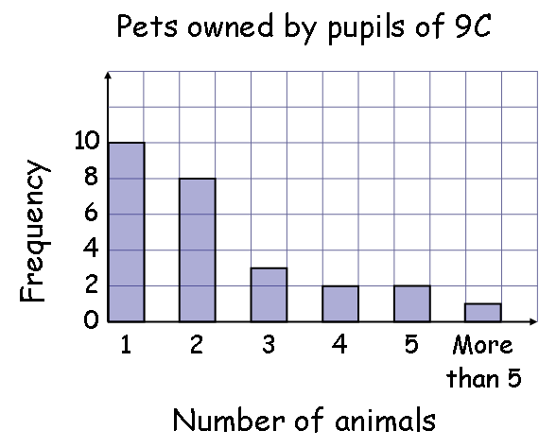

Vertical line graph
A vertical line graph is very similar to a bar chart except that each category has a line instead of a bar. Notice that the category labels are directly below each line.

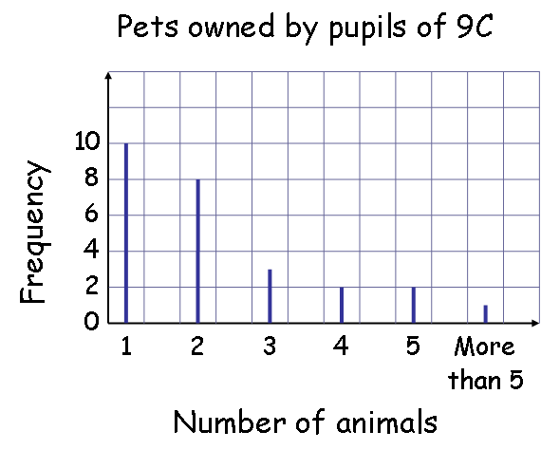

Pie chart/ Circle Graph
The complete circle represents the total frequency. The angles for each sector are calculated as follows:
Here is the data for the types of pets owned by 9C
Type of pet | Frequency | Angle of the sector |  |  |  |  | Divide 360° by the total of the frequency:  360° ÷ 36 = 10°  Therefore 10° represents one animal
Cats | 13 | 13 | x | 10° | = | 130°
Dogs | 11 | 11 | x | 10° | = | 110°
Birds | 5 | 5 | x | 10° | = | 50°
Fish | 7 | 7 | x | 10° | = | 70°
Total | 36 |  |  |  |  | 360°
Remember to check that the angles of the sectors add up to 360°.

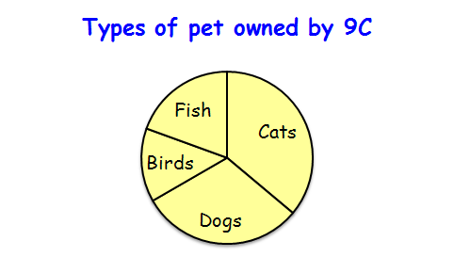

Continuous data
Displaying
With graphs representing continuous data, we can draw lines to show the relationship between two variables. Here are some examples:

Line graph
The temperature of water was measured every minute as it was heated and left to cool. A cross shows the temperature of the water at a specific time. Through connecting the crosses with a curve we see the relationship between temperature and time.
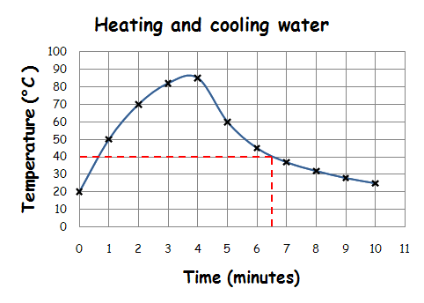
The line enables us to estimate the temperature of the water at times other than those plotted e.g. at 6½ minutes the temperature was approximately 40 °C.

Conversion graph
We use a conversion graph for two variables which have a linear relationship. We draw it in the same way as the above graph but the points are connected with a straight line.
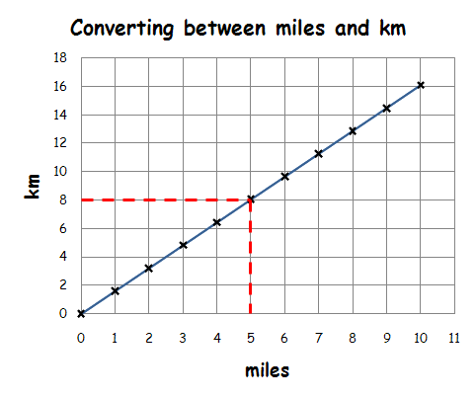
From the graph, we see that 8 km is approximately 5 miles.

Scatter Plot
We plot points on the scatter plot in the same way as for the line graph. We do not join the points but look for a correlation between the two sets of data.

Positive correlation No correlation Negative correlation

If there is a correlation, we can draw a line of best fit on the diagram and use it to estimate the value of one variable given the other.
The following scatter graph shows a positive correlation between the weights and heights of 12 pupils.
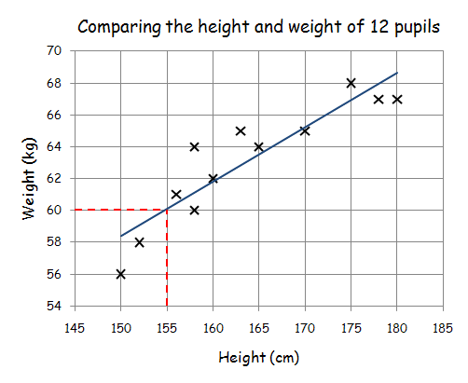
The line of best fit estimates the relationship between the two variables.
Notice that the line follows the trend of the points.
There are approximately the same number of points above and below the line.
We estimate that a pupil 155 cm tall has a weight of 60 kg.

Important things to remember when drawing graphs
- Title and label axes
- Sensible scales
- Careful and neat drawing with a pencil
Average
The average is a measure of the middle of a set of data. We use the following types of average:
Mean | - | We add the values in a set of data, and then divide by the number of values in the set.
Median | - | Place the data in order starting with the smallest then find the number in the middle. This is the median. If you have two middle numbers then find the number that’s halfway between the two.
Mode | - | This is the value that appears most often.
Spread
The spread is a measure of how close together are the items of data. We use the following to measure spread:
Range | - | The range of a set of data is the difference between the highest and the lowest value.
Example
Find the mean, median, mode, and range of the following numbers:
4 , 3 , 2 , 0 , 1 , 3 , 1 , 1 , 4 , 5
Mean |  | 4 + 3 + 2 + 0 + 1 + 3 + 1 + 1 + 4 + 5 |  | = 2·4
 |  | 10
Median |  | 0 , 1 , 1 , 1 , 2 , 3 , 3 , 4 , 4 , 5 | 2+3 | = 2·5
 |  |  | 2
Mode |  | 0 , 1 , 1 , 1 , 2 , 3 , 3 , 4 , 4 , 5 |  | = 1
Range |  | 0 , 1 , 1 , 1 , 2 , 3 , 3 , 4 , 4 , 5 | 5 - 0 | = 5
Vocabulary

Acceleration
Acute angle
Add
Angle
Approximation
Area
Average
Axis
Balance
Bearing
Bills
Bisect/Halve
Boundary
Calculator
Capacity
Cash
Circle
Circumference
Clockwise
Column
Compass (drawing circles)
Compass (points North)
Cone
Co-ordinates
Corresponding
Counter-clockwise
Cross-section
Cube
Curve
Cylinder
Cheapest
Decimal
Density
Deposit
Depth
Diagonal
Diameter
Dice
Digit
Dimension
Discount
Drawn to scale
East
Edge
Enlarge
Equal/Unequal
Equivalent
Estimate
Even number
Extend
Factor
Fraction
Frequency
Gradient (slope)
Height
Horizontal
Index
Interest (rate)
Intersection
Interval
Invest
Irregular
Layer/Tier
Length
Loan
Loss
Lower/Reduce
Mass
Maximum
Mean
Measure
Median
Minimum
Mode
Multiple
Net
North
Obtuse angle
Octagon
Odd number
Parallel
Percent
Perimeter
Perpendicular
Power
Pressure
Prime number
Prism
Probability
Profit
Pyramid
Quadrilateral
Radius
Range
Rate of exchange
Ratio
Rectangle
Reduce/Decrease
Reflection
Reflex angle
Remainder
Right angle
Round off
Row
Salary (income)
Save
Scale
Solution
South
Space
Speed
Sphere
Square
Square number
Square Root
Substitute
Symmetry
Total
Triangle
Triangular number
Unknown
Unlikely
Velocity
Vertex
Vertical
Volume
Weight
West
Width

